CHAPTER 1

1.1 INTRODUTION TO COMMUNICATION SYSTEM

The term communication refers to the sending, reception and processing of information by electrical means.
The unique feature of communications satellite is their ability to simultaneously link all users on the earth’s surface, thereby providing distance insensitive point-to-multipoint communications. This capability applies to fixed terminals on earth and on mobile terminals on land, in the air and at sea. Also with satellites capacity can be dynamically allocated to users who need it. These features make satellite communications systems unique in design.
Arthur C.Clarke , author of many famous books on exploration wrote WIRELESS WORLD in 1945 that a satellite with a circular equatorial Orbit at a correct altitude of 35,786 km would make one revolution every 24 h ; that is it would rotate at the same angular velocity as the earth. Clarke showed that three geostationary satellites powered by solar energy could provide worldwide communications for all types of services.
Satellites grouped into 3 categories

  - Geostationary (GEO)
  - Medium Earth Orbit (MEO) - 1000 to 2000Km
  - Low Earth Orbit (LEO)- Up to 1000Km

- Geostationary: These are placed in an orbit that is exactly synchronized with the earth.
- Low Earth Orbit: These orbit a few hundred miles above the earth. Like Global star, Iridium

Microwave

- This is a radio beam that uses very high frequencies to send and receive data.
- Transmission is aimed in a single direction to prevent others from intercepting the signal. Stations are placed ~30 km apart.
- Carries more information than low-frequency RF transmissions.
- Microwaves cannot penetrate metal structures. Stations must be visible to each other.
- Many long-distance telephone companies use microwave as their transmission medium.

1.2 SATELLITE COMMUNICATION

- Based on radio frequency (RF) transmissions.
- Satellite communication systems consist of ground-based or Earth stations (parabolic antennas) and orbiting transponders.
- The transponder receives a microwave signal from the ground unit (uplink) amplifies it and then transmits it back to earth (downlink).
- Two satellites using the same frequency will interfere with each other, if they are placed close together.
- To avoid this, current standards require a 4-degree spacing (angular displacement) at the same altitude.

The downlink and uplink frequencies used in ONGC are:

C-Band Transmit
TxIFCTRFREQ +LO
1.3 GHz + 4.9 GHz
TxRFCTRFREQ
6.2 GHz or
6200 MHz
MODEM
BUC
Tx
L-Band
C-Band
~ LO = 4.9 GHz
TxIFCTRFREQ = 1300 MHz or
1.3 GHz
=
=

LO - RxIFCTRFREQ
5.15 GHz - 1.3 GHz
RxRFCTRFREQ
3.85 GHz or
3850 MHz
MODEM
LNB
Rx
L-Band
C-Band
~ LO = 5.15 GHz
RxIFCTRFREQ = 1300 MHz or
1.3 GHz
Rx - Spectral Inversion
=
=
1.3 MULTI FREQUENCY TIME DIVISION MULTIPLE ACCESS
Multiple frequency time division multiple access (MF-TDMA) transmission, which uses a multiplicity of frequencies and time slots simultaneously, provides a high data bit rate. This is why it is used in the DVB-RCS standard, currently in preparation, which concerns the transmission via satellite of digital data (audio, video, Internet, etc.).
In the above type of telecommunication system, each carrier, which has a particular frequency, offers a given number of time slots per frame, the number of time slots per frame being equal to 1 or to a power of 2, for example.
Messages are transmitted in superframes containing a particular number of frames. A frame, which comprises a particular number of carriers and time slots, is transmitted during a particular time and a superframe extends over a number N of frame durations and includes a number N ₁ of carriers.
During a frame, the same message may be transmitted on several different types of carrier, which is to say with time slots of different duration.
As a general rule, MF-TDMA calls can be “star” calls, i.e. calls made through the intermediary of a base station. In other words, a terminal communicates with another terminal via the base station. It is also possible to effect calls directly between terminals, without passing through the base station, and this type of call is called a “meshed” call. It is also possible to combine star calls and meshed calls.
It has been found that in the above type of telecommunication system the frequency hops for the same terminal can have large values, which makes the implementation of the terminals of the above kind of telecommunication system relatively complex.
An object of the invention is to enable total (star and meshed connection) connectivity using terminals having limited performance in terms of send and receive frequency hopping and using the MF-TDMA technique to send and receive.
The invention therefore calls for terminals equipped with an MF-TDMA modulator for star sending (to a base station) or meshed sending (to other terminals) and an MF-TDMA demodulator for meshed reception (from other terminals).

1.4 SATELLITE FREQUENCY BANDS

Communications systems employ electromagnetic frequency spectrum. The frequencies used for satellite communications are allocated in the super high-frequency (SHF) and extremely high-frequency (EHF) bands which are broken down into sub bands.

1.4.1 Electromagnetic frequency spectrum

Frequency Designation

3 Hz- 30 kHz very low frequency band (VLF)
30 KHz- 300 KHz low frequency (LF)
300 KHz- 3 MHz medium frequency (MF)
3 -30 MHz high frequency (HF)
30-300 MHz very high frequency (VHF)
300 MHz- 3 GHz ultra high frequency (UHF)
3-30 GHz super high frequency (SHF)
30-300 GHz extremely high frequency (EHF)

1.4.2 Satellite frequency spectrum

Frequency band Range (GHz)

L band 1-2
S 2-4
C 4-8
X 8-12
Ku 12-18
K 18-27
Ka 27-40
Millimeter 40-300

Spectrum management is an important activity which is done under the auspices of the International Telecommunication Union (ITU) which is a specialized agency of the United Nations (UN).

1.4.3 Technical Parameter of C-Band

Satellite : (INSAT 3E)
Location : 55Deg East
Txp No. : 15
Bandwidth : 36 MHz
Polarization : Linear
EIRP of Txp : 38 dbw
Center Frequency of Transponder:
Tx Frequency - 6050 MHz.
Rx Frequency - 3825 MHz.
Beacon Frequency:
Beacon Frequency # 1 - 4197.504 MHz.
Beacon Frequency # 2 - 4191.00 MHz.

1.5 INSAT-3E
INSAT-3E was launched on September 28, 2003. It is positioned at 55 degree East longitude. The payloads of INSAT-3E are the following:
• 24 Normal C-band transponders providing an edge of coverage EIRP of 37 dBW over India.
• 12 Extended C-band transponders providing an edge of coverage EIRP of 38 dBW over India.

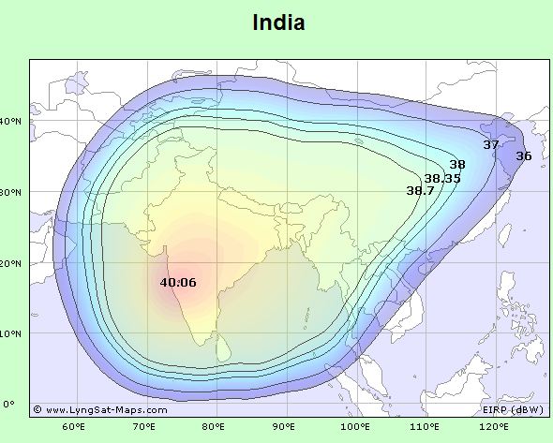

EXHIBIT 1.1 THE AREA COVERED BY THE INSAT-3E

CHAPTER 2

  - PROJECT OVERVIEW

Oil And Natural Gas Corporation Limited (ONGC) is India’s premier organization engaged in exploration and exploitation of hydrocarbons with its Registered Office at Jeevan Bharati in New Delhi, Head quarter at Dehradun and Regional Headquarters & Work Centers spread all over India makes significant contributions to the industrial and economic growth of the country. The operations of ONGC in India are organized and managed through geographically distinct Assets, Basins, Forward Base, Regional & Corporate offices. ONGC needs to deploy advanced technology in all facets of its multidisciplinary activities, to sustain efficiency of operations and to remain competitive in the emerging open economy. As a part of the IT Strategy, ONGC has set up its own captive communication network comprising of both Terrestrial as well as Satellite based systems connecting its various work centers spread over the country.

2.2 SYSTEM FEATURES

The objective of the present project is to induct state-of-the-art Satellite based communication systems in ONGC’s onshore field Installations consisting of Production, Drilling and Exploration sites to ensure reliable data and voice connectivity to the above field installations.

- Providing communication links between the field locations and their respective Assets/Basins for Enterprise Wide on-line SCADA to facilitate analysis of valuable well / Process data and Drilling data available in the SCADA servers.
- To ensure access to various corporate wide I.T. applications like SAP, Intranet/internet, e-mail from these field installations.
- Provide seamless voice communication to these installations to enable them to communicate with the other work centers.
- To achieve the above objective it was proposed to implement an enterprise wide Satellite Based Communication Network for ONGC’s Field Installations based on best-in-class technology. The System has been designed to provide the following facilities:
- Fully integrated, centrally managed solution which provides simultaneous star and full mesh connectivity for data and voice applications with a converged Internet Protocol (IP) solution.
- VSAT TT shall support dynamic routing protocols such as RIP1,RIP2. It should be able to support static and default routes and IGMP protocol for multicast applications.
- Network will support any VSAT to any VSAT single hop connectivity over IP.VSAT should support QoS features to give priority to traffic on application.

The network is capable of handling fast data rates and shall be based on IP technology to provide a highly reliable and bandwidth efficient solutions in a single satellite hop for providing Voice & Data communication:
A. Voice
Between field Installations and respective Asset/Basin HQrts.
Among the field installations within an Asset/Basin.
Between field installations and other work centers outside Asset/Basin.
B. Data
Between field installations and respective Asset/Basin HQrts.
Between field installations and Data Centre at Delhi
Among Assets/Basins HQrts.
Between Assets/Basins HQrts at Delhi and Dehradun

2.3 FACILITIES SETUP UNDER THE PROJECT
2.3.1 Satellite/Transponder:
The proposed Network operates in C-Band and utilizes the leased transponder #15 on INSAT-3E.
2.3.2. Earth Stations/VSATS:
The network in the proposed configuration constitute about 184 satellite/VSAT stations and shall have expandability to at least 500 stations having capability of full transponder bandwidth of 36 MHz with out requiring any further addition of hardware or software at the Network HUB, NMS/ NCC.
Note: The Network Hub here means the hardware/software for the NCC and MRT – but does not include Traffic Hardware.

2.3.3. Network Operating Centre
The Network Control Center has been setup with Redundant in 1+1 configuration hardware of indoor Units comprising of Satellite Modems and NCC/NMS equipments, interfacing hardware, connector, cables etc. at the existing satellite earth station, Dehradun along with AVAYA VoIP Server and gateway in 1+1 configuration for Voice Solution.

2.3.4 Augmentation of Existing Satellite Earth Stations
18 existing Satellite Earth stations/VSATS have been augmented with LINKWAY IP SATCOM Modem (TT) by utilizing the existing Antenna and RF system. The LINKWAY modem has been integrated at the IF stage by using L band to IF (70MHz) converter. These stations shall operate in full mesh configuration and are capable of handle all data and VoIP calls between these stations and their respective field installations. TT has been integrated with Local LAN at L3/L2 switch. For voice connectivity AVAYA make VoIP solution has been implemented. Under this project a centralized fully redundant server and Gateway (G650) has been installed at Dehradun and distributed Gateway (G700) installed at various 20 locations for integrating existing Exchanges (through PRI) with AVAYA Gateways to facilitate the users of existing Exchanges can call VoIP Subscriber at remote field locations and vice versa.

2.3.5 Remote NOC at Data Centre-Delhi

A Remote Network Management Terminal of the NMS from Dehradun extended over WAN link to the Central Network Operating Centre (NOC) of ONGC communication infrastructure at Delhi, such that the proposed network can be monitored and managed from the Central NOC.

2.3.6 Productions and other fixed Field Installations.
VSAT stations having 3.8M/2.4M antenna along with 10 W BUC have been established at various fixed field installations in the Assets such that these locations along with VoIP phones and Data connectivity for SAP, SAMPARC, or.NET, INTERNET & SCADA applications. These stations shall be capable of delivering minimum up to 512 kbps in case of 3.8 M VSAT and 256 kbps in case of 2.4M VSATs, which would include Voice calls. The IDU for both types of VSATs should be capable of delivering 2Mbps throughput, which shall include minimum of 4 simultaneous Voice calls.

2.3.7 Drilling Rigs
Onshore Drilling Rigs
There are about 71 onshore Drilling rigs, which are operating at present in ONGC. These drilling rigs are nomadic in nature that is they keep shifting over a period of time from one field location to other.

VSAT stations at these sites have light-weight 2.4M antenna system and equipped with 10W BUC, that can be easily dismantled and re-installed during the course of shifting of these rigs. The VSAT stations of the drilling rigs shall work in star topology with Dehradun as the HUB station. Access to SCADA Data, internet/Intranet and Mail shall be through Dehradun, while ERP data shall have alternate access routes. These stations are capable of delivering up to 256 Kbps of Data rates (depending on the various parameters); which include minimum 2 simultaneous voice (VoIP) channels.

2.3.7.2 Offshore drilling rigs
There are 8 Offshore Drilling rigs. These VSATS are augmented with LINKWAY IP SATCOM modem (TT) for Data & Voice communication. For voice communication EPAX and PSTN numbers from Mumbai are extended. Necessary VoIP gateway has been installed and integrated Local exchange at Mumbai.

2.3.8. Exploration field parties

There are about 26 onshore exploration field parties. 2.4M VSATS have been installed along with 10W BUC. These VSATS are capable of delivering minimum up to 256 Kbps of Data include 2 simultaneous voice (VoIP) channels.

CHAPTER 3

3.1 SATELLITE COMMUNICATION SETUP AT DEHRADUN


INSAT-3E
COMBINER
UP CONVERTERS
MOD
DEMOD
MOD
DEMOD
MOD
DEMOD
SPLITTER
NETWORK
MANAGEMENT
and CONTROL
DN CONVERTERS
LOW NOICE
AMPLIFIERS
HIGH POWER
AMPLIFIERS
MUX
RADIO
MUX
RADIO
18GHz RADIO Link
TELNET/HOTLINE EPAX
KDMIPE
TEL BHAVAN
VOICE CH.
DATA CH.
24
38
ROUTER/SWITH

EXHIBIT 3.1: THE SATELLITE EARTH STATION


L2SWITCH
MRT
TT-5
TT-8
TT-7
TT-6
TT-1
TT-2
TT-3
TT-4
L-BAND SPLITTER
NCC2 (COLD STANDBY) SUN SERVER
AMRT
L-Band
CONVETER
(IF to L)
UP
CONVERTER
(IF to RF)
DOWN
CONVERTER
LNA
(Low Noise Amplifier)
ANTENNA
SECTION
Transmit Path
Receive Path
L3
S
W
I
T
C
H
NCC1 (ACTIVE)
SUN SERVER
L-BAND COMBINER
NMS PC
DOWN
CONVERTER
(RF TO IF)
AVAYA SERVER

HPA
(HIGH POWER AMPLIFIER)
L-Band
CONVETER
(L to IF)

EXHIBIT 3.2: THE MF-TDMA NETWORK AT THE SATELLITE EARTH STATION

TRANSMIT: As we can see in Exhibit 3.2 the signal when prepared is send to the upconverter to convert the signal from IF to RF. Then the signal is amplified using solid state power amplifier which is a much better technology from Traveling wave tube amplifier (TWTA). Now the signal is send to the feed of the antenna which gives the signal to the reflector which finally transmits the signal.

RECEIVE: On the receive side the signal gets reflected by the reflector to the feed which connects to a waveguide that takes it to the Low Noise Amplifier (LNA). The LNA amplifies the signal without adding much of noise to the signal. The signal now goes to the coupler so that both the existing as well as redundant system can work in case the existing instrument fails. Now the signal enters the earth station through the waveguide and gets its signal down converted from RF to IF band. The instrument used is Comtec DT4503 Downconverter. Now the IF inputs are given to the DAMA and PAMA systems. The PAMA system is used for data transfer and uses Modem DMB 2401. The DAMA system is used for voice and the modem used is scientific attenuator. One of the inputs goes to the MF-TDMA rack where the IF input is converted to L-band frequency as the system works only on L-band frequency and on completion of the work of the system the signal is again down converted to IF frequency to be input to the transmit system. The MF-TDMA system is working on the VOIP and DATA transfer.

Besides the above system the earth station also contains an Antenna control unit which tracks the satellite and moves the antenna in both the azimuthal as well as vertical direction.
Our mission is to implement the MF-TDMA technology in addition to the existing DAMA and PAMA system. Further optimizing the system in order to get the best bandwidth utilization maintaining the quality of service
There are following three sections to explain the features of network:

- The Network explains features and capabilities of the MF-TDMA networking equipment across a variety of applications.

- Network Components describes the physical elements of the MF-TDMA network site—the indoor unit, the outdoor unit, and the Network Control Center hardware.

- Network Operations demonstrates how network uses TDMA to efficiently provide Internet Protocol services.

3.1 THE NETWORK

- The MF-TDMA network is a multi-carrier, multi-rate, time-division multiple access (TDMA), VSAT-like (very small aperture terminal) platform that works with conventional satellites.
- It provides seamless full-mesh connectivity for flexible, on-demand broadband corporate networking applications.
- The system automatically allocates satellite bandwidth on a call-by-call basis, based on dynamically measured traffic levels or on a fixed-assignment basis, if required.
- It terminal uses an L-band RFT interface in support of broadband applications that span multiple satellite transponders.
- In addition to efficient TDMA and automated bandwidth on demand (BoD), it eliminates the need for additional third-party networking equipment. This result in improved overall network reliability, lowered costs, and simplified integration with terrestrial networks.
- This network platform incorporates enhanced features providing a unique architecture that supports mesh, star, virtual star, and hybrid topologies.
- This network broadband VSATs support multiple antenna and RF transceiver configurations with flexible carrier parameters that include variable bit-rates, power levels, and forward error correction (FEC) settings for each carrier.
-  The outdoor unit (ODU) includes a radio frequency terminal (RFT) and an antenna. The RFT consists of a solid state power amplifier (SSPA) and block up-converter (BUC). The terminal and ODU are connected by an interfacility link (IFL), which includes both a transmit (Tx) and a receive (Rx) cable. It may be the case that RFT is integrated into the terminal and provides an L-band IF interface.
- The heart of the network is the Network Control Center (NCC)—a Sun workstation—which provides the management and control functions for all network terminals. The NCC is the platform for the Network Management System (NMS) server. The NMS is the graphical user interface accessed using standard web browser, which the user accesses to configure the network and to request information from the NCC. The system supports NCC redundancy to increase network reliability.

Exhibit 3.4 illustrates four sites in a single network, with its NCC and NMS collocated with a terminal and ODU combination, called a site.

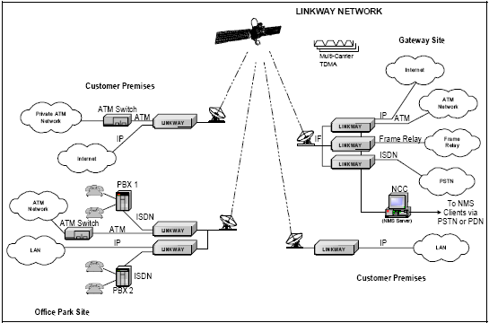

Exhibit-3.4: The Network

An effective broadband VSAT platform must provide the following capabilities in order to address today’s diverse multimedia networking applications, which are discussed below:

    - Support For a Broad Range of Network Topologies

The three most popular and regularly encountered topologies include star (hub-and-spoke networks), mesh (any-to-any connectivity in one satellite hop), and virtual star (hybrid networks with multiple hub locations). These are illustrated in Exhibit 3.5:

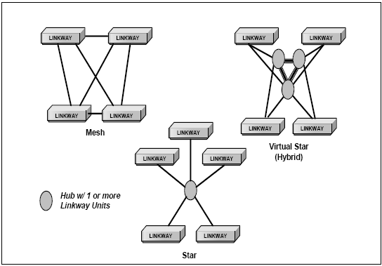

Exhibit 3.5: Three topologies and one platform

- A typical star network consists of a central hub location with many remotes supporting asymmetric outbound and in-bound traffic requirements.

- A mesh network consists of many terminals with one or two assigned to administer the network, no central hub location (although optional higher traffic gateways are possible), and support for any-to-any connectivity. Applications include telemedicine, corporate wide-area voice and data communications, LAN extensions and videoconferencing.

- A virtual star or hybrid net-work consists of two or more hubs or gateways and provides mesh connectivity between hubs, remote-to-multiple hub connectivity, and asymmetric data rates. Virtual star networks are essentially two-tiered topologies supporting high-traffic gateways with mesh connectivity to each other and small remote locations that are connected to the high traffic gateways. Each tier requires links that provide fiber-like bit error ratio (BER) performance and asymmetric transmission rates. Typical applications include multinational corporate intranets, and service provider operated virtual private network.

3.1.2 Efficient Demand Assigned Bandwidth Management

The network system runs a central bandwidth management program in order to efficiently use space segment and provide high levels of end-user data throughput. The bandwidth management function performs both fixed bandwidth allocation and dynamic bandwidth allocation (bandwidth on demand):

- Fixed bandwidth allocation—Certain traffic categories in ATM and Frame Relay, and the circuit-switched nature of ISDN calls, require bandwidth to be allocated for the entire duration of the call.

- Dynamic bandwidth allocation (bandwidth on demand)—Every terminal runs a Bandwidth Reporter program that continuously monitors the incoming user traffic. The dynamic bandwidth allocation function collects the reports from all traffic terminals and periodically runs an algorithm to distribute available bandwidth resources fairly and efficiently using three levels of fairness. This algorithm provides bandwidth allocation in response to changing incoming user traffic rates in a dynamic manner.

3.1.3 Diverse Network Applications

This technology is particularly well-suited to the diverse topologies needed for today’s wideband networks. Service providers and multinational corporations can economically establish mesh, star, or virtual star networks using a single platform. This is important for service providers, because:

- Mesh networks support teleconferencing requirements.
- Star networks support internet access and data distribution.
- Virtual star networks support corporate data intranets connecting remote offices to headquarters, factories, and MIS centers.

Popular broadband VSAT network examples, described below, include:

- Virtual private networks.

- Private corporate networks.

- Internet service providers.

- Real-time digital video internetworking.

- Wireless interconnectivity.

- Disaster recovery.

PRIVATE CORPORATE NETWORKS

Private multinational corporate networks encounter a wide variety of applications, such as intranets and LAN extensions. Typical requirements include file and image distribution, inventory control, video conferencing over ISDN and IP, e-mail, database backup, voice-over-digital PBXs, and voice over IP. Because it is configurable for any network topology, corporations can affordably provide broadband content to and from multiple locations. A multiple-services corporate network is illustrated in Exhibit 3.6.

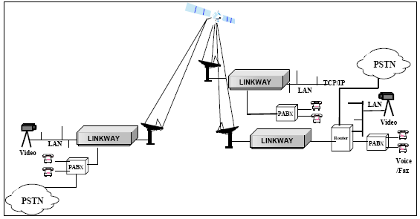

Exhibit 3.6: MULTIPLE SERVICES PRIVATE CORPORATION NETWORK

3.2 NETWORK COMPONENTS

OUTDOOR
INDOOR
C
F
C
M
SSPA Power
Supply
48V External Power Supply or A/C
(C-band, 10W and above; Ku-Band, 8W and above)
OUTDOOR
INDOOR
LEGEND
D9
= 9-Pin D Connector
F
= F Connector
M
= Metal Circular Power Connector
N
= N Connector
RJ
= RJ11 Connector
C
= Plastic Circular Power Connector
N/F
= N to F Adapter
Gender is indicated by a subscript M or F
(e.g., N
F
represents a female N connector)
Tx IFL 24V
and 10MHz
SSPA
M
F
M
M
F
F
F
M
F
M
N
F
WR75 or
WR137 (To
Antenna)
BUC
RJ
F
F
F
MODEM
Tx
Rx
Console
IFL Cable Length 30, 60, 100, or 150 Meters
RJ
M
RJ
F
/D9
M
D9
F
Computer
RS232
Interface
F
M
Rx IFL 24V
and 10MHz
F
M
F
F
LNB
WR75 or
WR229 (From
Antenna)
-75 to -35 dBm
Optimal = -55dBm
L-Band, -30 to 0 dBm
-30 to -25 dBm (max)
Connector
supplied with
BUC/SSPA
Console cable & DB-9
Adapter supplied with
MODEM
RJ
M
N_{M}F_{F}

EXHIBIT 3.7: BUC AND BOOSTER BLOCK AND LEVEL

The network consists of sites managed by a Network Control Center (NCC) workstation at one of the sites. The MF-TDMA setup hardware as shown in the Exhibit 3.7 includes:

- The Terminal

- The outdoor unit, or ODU, which consists of the radio frequency terminal (RFT) and antenna.

- The NCC, which includes a Sun work-station and a PC.

3.2.1 THE INDOOR UNIT

The MF-TDMA terminals are housed in compact rack-mountable packages with 70 MHz (or L-band) interfacility links (IFL) to radio frequency terminals (RFTs) operating in C-, Ku-, or Ka-band.

Basic Criteria for Selection of the IFL RF Cables

1. Tx DC resistance: <1.5 ohm
2. Cable Loss must be considered to achieve correct Tx or Rx power level
- Tx IF loss: -25 to -30 dBm input max. to BUC
- Rx IF loss: approximate loss for LMR-400 is 14dB for 100m cable
4. 10 MHz loss: <5 dB
5. FSK signal loss: <5 dB

It incorporates a multicarrier, multi-rate, time-division multiple access (TDMA) modem. Each carrier in the network may be configured with differentspeeds and forward error correction (FEC) rates. Larger carriers increase terminal throughput but also increase outdoor unit (ODU) power and size requirements. Smaller carriers limit connectivity to star or partial-mesh topologies, but also reduce capital investment per remote terminal. With the exception of the ODU size, the system administrator can modify the configuration at any time.
As many as 256 carriers can be supported in a network. Initially, however, only one carrier is needed for each network. Additional carriers can be added as the network traffic increases. All carriers in a transponder can be automatically shared among the users on demand. Assignment of terminals to carriers is performed dynamically by the Network Control Center (NCC) collocated with one terminal.

The Network supports five modem symbol rates:

- 312 ksps
- 625 ksps
- 1.25 Msps
- 2.5 Msps
- 5 Msps

ONGC MFTDMA network has got twelve (12) carriers. Ten of them is of 625 ksps ,one of 1.25 Msps and one of 5 Msps.

The Modem Performance Table in Exhibit 2- 4 provides a performance summary and a throughput range based on carrier size and coding rates. The actual observed throughput of a sys-tem will be dependent on multiple factors within the TDMA frame structure. The following are true throughout the performance summary:
- (236,216) Reed Solomon coding is applied to all carriers.
- Modulation is QPSK
- The modem has a rolloff factor of 0.4; the carrier spacing factor is 1 +(roll-off) = 1.4. Thus the allocated bandwidth is the symbol rate x 1.4
- 0.8 dB of implementation loss should be added to the C/N and E_{ib}/N_{o} for link budget calculations. Table 3.1 shows the BER for various Carriers.

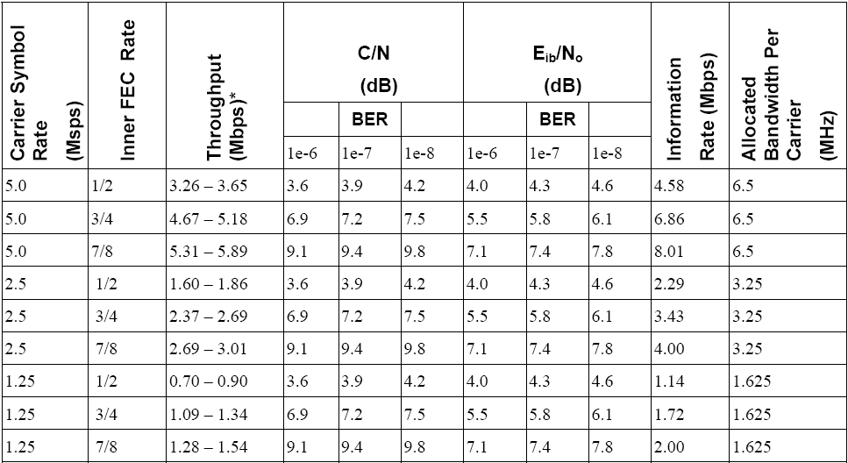
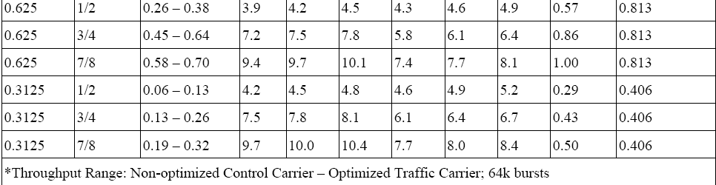
TABLE 3.1: THE BER FOR VARIOUS CARRIER SYMBOL RATES

3.2.2 The Outdoor Unit

The Radio Frequency Terminal

The Ku-Band transceivers can be configured for 2-, 4-, 8-, 16-, or 25-Watt operation and the C-Band transceivers for 5-, 10-, 20-, 40-, and 60-Watt operation:

- The RFT consists of two primary elements: An RFT indoor unit, which acts as interface between the modem and the BUC, and an RFT outdoor unit, which consists of BUC and an SSPA or booster amplifier integrated with the BUC.
- RFT’s interface accepts a 70-MHz modulated signal from the terminal and outputs a modulated L-Band signal to the block up-converter (BUC). A monitoring feature verifies system status and isolates faults in the field-replaceable unit.
- A control feature enables locally or remotely selecting uplink and downlink operating channels and adjusting transmitted power.

3.2.3 The Network Control Centre

The NCC performs overall management and control of the network. Network configuration is defined at the NCC and automatically distributed to the terminals. The NCC can be configured in a redundant or non-redundant architecture, either at the same site or at geographically separated sites.
A single traffic terminal is always designated as Master Reference Terminal (MRT) and connected to the NCC using a 10-BaseT Ethernet interface. The NCC then communicates with other terminals through the MRT via the satellite link. The system does not require a dedicated terminal for NCC connection or reference terminal purposes, and the MRT also carries user traffic.
Operators located remotely can log on to the NCC using PCs (or Macs) with Web browsers. This remote client—the Network Management System (NMS)—is the operator’s interface to the network configuration and status screens.
The NCC is a hosted Sun Ultra 5 workstation. Exhibit 3.8 illustrates a Geo-Redundant NCC setup.

ANCC Server
NCC Server
MRT
AMRT
Layer-3 Switch
Layer-3 Switch
Leased Line
Leased Line
Delhi Router
Dehradun
Router
URAN
Router
Backup
NCC Server
Backup
MRT
Layer-2 Switch
Layer-2 Switch
EXHIBIT 3.8: ONGC GEO-RED SETUP

3.3 NETWORK OPERATIONS

3.3.1 TDMA Architecture

In order to access the space segment, the terminals uses time division multiple access (TDMA) techniques. Frame Format and Hierarchy describes the frame format and hierarchy that the network uses.

Frame Format and Hierarchy

A TDMA frame is the basic periodic interval of time during which a terminal transmits or receives one or more bursts. The frame duration has a nominal value of 27 ms and can be programmed from 12 ms to 48 ms in 1-ms steps. Every frame boundary is delineated by a start-of-frame (SOF) instant—a point relative to the position of the beginning of the first symbol of the reference burst in the frame. Each reference burst frame is identified numerically by a frame identifier.

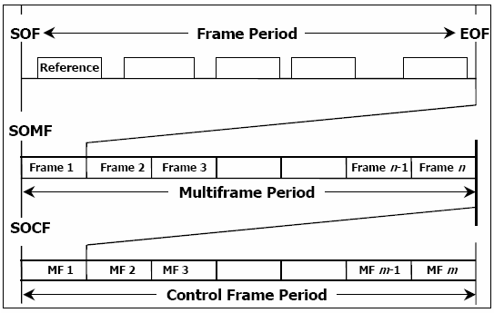

EXHIBIT 3.9: TDMA FRAME HIERARCHY

Each carrier in a multi-carrier operation transports a TDMA frame that is time aligned with all other carriers’ frames on SOF, start of multiframe (SOMF), and start of control frame (SOCF). A multiframe is the duration of N consecutive frames. The nominal value for N is 8. Multiframe boundaries are delineated by an (SOMF) instant encoded in the frame identifier. The terminals transmit and receive bursts on specified frames of the multiframe.
A control frame is the duration of M consecutive frames. The nominal value for M is 128. Control frame boundaries are delineated by an SOCF instant encoded in the frame identifier. The network transmits and receives bursts on specified frames of the control frame.

TDMA Burst Structure

The burst is the high-level unit of transmission, with multiple burst types providing efficient space-segment use. The Table 3.2 illustrates the Burst Types.

Burst Type | Transmitting Terminal Type | Purpose
Reference Burst  (RB) | Reference | - Conveys outbound NCC Signaling.  - Conveys timing feedback data to traffic terminals.  - Establishes receive timing.
Signaling Burst  (SB) | Traffic | - Conveys inbound traffic terminal signaling.
Acquisition  (AB) | Traffic | - Conveys transmit response message.  - Used to acquire traffic terminal transmit timing.
Control Burst  (CB) | Traffic | - Conveys traffic terminal status report.  - Used to maintain traffic terminal transmit timing.
Traffic  (TB) | Reference &Traffic | - Conveys circuit and packet data.

TABLE 3.2: BURST TYPES
In order to establish a connection between the HUB and the Remote Site the remote site has to demand for bandwidth. Hence the Remote Site has to send the Signaling and the Control Burst to the MRT. The site also sends the Acquisition Burst once at the time of connection establish in order to establish traffic terminal transmit timing. In response the MRT sends the Reference Burst in order to establish receive timing response and the NCC signals to the remote traffic terminal. The Traffic Burst is send both ways to transfer data.

The burst is the high-level unit of transmission, with multiple burst types providing efficient space-segment use. The burst structure has the following elements:
- The carrier and bit timing recovery (CBTR) data pattern aids receiving modems in obtaining carrier and symbol clock acquisition. The CBTR consists of 128 consecutive symbols of alternating binary 1's and 0's. The CBTR beginning defines the burst position in the frame.
- The unique word (UW) data pattern aids receiving modems in locating the first symbol of the first channel in the data field. The UW consists of 48 consecutive symbols. Reference bursts have a UW that differs from non-reference bursts.
- Channel structure—Bursts can simultaneously carry any combination of 64 kbps circuit or packet data within their channels, with up to 8 channels present in a burst. Circuit-data channels are simply filled with encoded data. Packet-data channels contain many packets of varying length. To facilitate error detection and depending on correction, Reed-Solomon check bytes are included in both circuit- and packet-data channels.
- Guard time—every burst is defined in the frame with guard space to prevent transmit burst timing errors from resulting in burst overlap and loss of data. Each terminal’s bursts are controlled in order to limit timing variations at the satellite to ± 1/2 guard time. The TDMA Burst structure in shown in Exhibit 3.10.

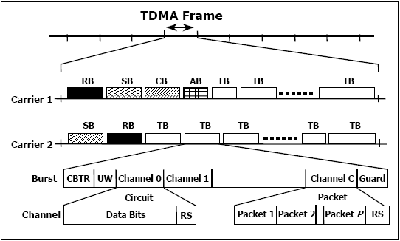

EXHIBIT 3.10: GENERAL TDMA BURST STRUCTURE

3.3.2 Single-Beam and Multiple-Beam Operation

The system is designed for both single-beam and multiple-beam operation. As shown in the figure, in the single-beam case, all terminals have transmit and receive access to all carriers assigned to the system. The MRT directly supports all terminals. In the multiple-beam case, terminals have transmit access to one set of carriers and receive access to another. The MRT supports terminals in Beam 2 and the supporting reference terminal (SRT) supports traffic terminals in Beam 1. The Beam configurations are shown in Exhibit 3.11.

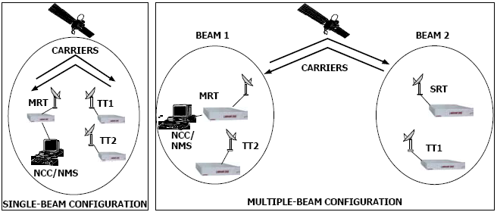

EXHIBIT 3.11 SINGLE AND MULTIPLE BEAM CONFIGURATIONS

3.3.3 Clock Management

- To minimize timing error in the system, each terminal automatically monitors and adjusts its direct digital synthesizer (DDS) to match that of its MRT or supporting reference terminal.

- To further minimize timing error, an industry-standard, highly accurate external clock source can be connected to the reference terminal as an option. The reference terminal’s DDS tracks the external clock in frequency and phase, while all other terminals continue to track the reference terminal’s DDS. This is a cost-effective method for highly accurate timing throughout the system.
- Without an external clock source, the DDS is accurate to 1 part in 10⁷. An accurate external clock typically raises accuracy to 1 part in 10¹¹. The clock

generation algorithm is shown in Exhibit 3.12.

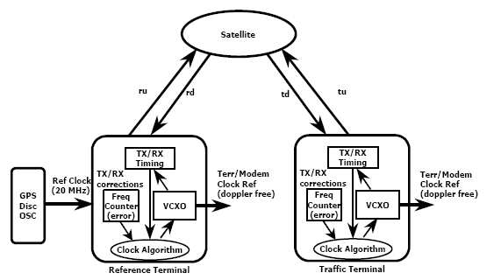

EXHIBIT 3.12: CLOCK GENERATION ALGORITHM

Uplink power control (UPC) compensates for degradation on the uplink of any traffic terminal in the network. Degradation can be caused by rain or other weather conditions, or by changes in the up-link equipment chain because of aging or temperature changes.
The network’s uplink power control uses a proprietary algorithm to adjust the transmit power burst by burst so that each burst’s BER stays within the specified BER range. This translates into burst-by-burst power settings that accommodate bursts of different symbol rates being affected differently by changing conditions.
To support the UPC algorithm, the following specifications are defined for each terminal:

- UPC Enabled—Shows if UPC is enabled.

- Minimum Power—Minimum allowed Tx power.

- Maximum Power—Maximum allowed Tx power.

- Target BER Low—Maximum required performance BER.

- Target BER High—Minimum acceptable performance BER.

- BPSK BER—BER at which BPSK becomes the preferred modulation.

- QPSK BER—BER at which QPSK becomes the preferred modulation.

- Clear Sky BER—Nominal reference burst BER during clear sky conditions.

- Tx Power—Initial transmit power for 2.5 Msps bursts; this value is scaled for bursts of other symbol rates.

UPC uses three logical entities:

- Measuring terminals—Each terminal, upon connecting to the NCC, becomes a measuring terminal. It tracks the number of Viterbi errors, Reed-Solomon corrections, and bits transmitted on each reference burst received. The terminal aggregates the data into burst groups by source terminal, destination terminal, carrier-ID and burst type. Measuring terminals also compute their own downlink fade index by comparing the BER of the received reference burst with the normal clear sky BER. Periodically, measuring terminals report these statistics.

- The NCC—Using a proprietary algorithm, the NCC analyzes each measuring terminal’s data and index, and then:
  - Increases the power of burst groups with BERs worse than the Target BER High and decreases the power of those with BERs better than the Target BER Low.
  - Can switch a terminal to prefer BPSK if the BER of any of its
transmit burst group exceeds the BPSK BER.
3. Can switch a terminal to prefer QPSK if the BER of all of its transmit
bursts groups are better than QPSK BER.

- Measured terminals—Any terminal transmitting a burst is a measured terminal. When a measured terminal first establishes a link to the NCC, it reports its current burst group transmit power settings. When a measured terminal receives an NCC request to adjust a burst groups transmit power, it makes the requested adjustment and reports the new value back to the NCC.

CHAPTER 4

4.1 THE NETWORK MANAGEMENT SYSTEM

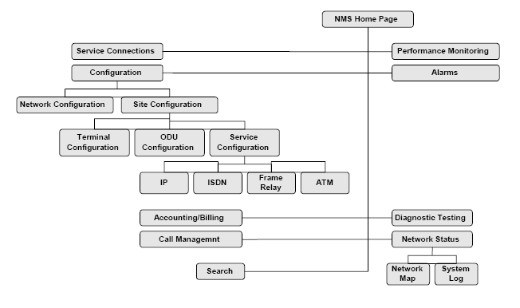

EXHIBIT 4.1: NMS Window Hierarchy

The NMS window hierarchy is shown above in Exhibit 4.1. The MF-TDMA Network Management System (NMS) consists of a set of HTML files and Java Applets downloaded from the World Wide Web (WWW) Server via HTTP and run on a client Web Browser, such as Netscape or Internet Explorer. The MF-TDMA NMS uses graphical interfaces to provide central network management functionality. Since the NMS is developed in Java, any number of NMS client systems, running on any platform (Sun, PC, Mac, Windows 95, Windows NT, or Motif) using any Java-capable Web browser can be used to access the NMS server. In addition, interfaces and support are provided to allow information to be shared with other operational systems, such as billing systems.
The NCC communicates directly with the MF-TDMA Master Reference Terminal (MRT) over Ethernet and with all other terminals in the system through the MRT over the satellite network.
A successful login displays the MF-TDMA NMS Home Page window, a map showing the status of the MF-TDMA network. The home page enables the NMS operator to view sites and terminals geographically and readily obtain status and configuration information. When a detailed map is available, zoom selection displays a larger map of the area and shows the terminal icons. Map graphics can be enhanced for each customer’s applications. Use the buttons in this window to access configuration and status information functions. The MF-TDMA NMS performs five primary functions, which are described in detail in this manual:

4.1.1 Network Status Reporting

The NMS User checks network status through the NMS Home Page window and the Network Status button:

Network Status Map ----Opening the NMS Home Page window displays a world map. This map shows all configured sites in the user’s network, Color coded as to current status.
Network Status Button—Yields detailed information on the site status, terminal status, and a log of all major network events.
Burst Time Plan — Displays the current burst allocations on each carrier, providing a view of current traffic activity in the network, with each burst type color coded. The display is dynamically updated as bandwidth is allocated and de-allocated, graphically showing bandwidth on demand in real time. Bursts appear and disappear as the NCC, monitoring the network, allocates and de-allocates bandwidth based on user traffic requirements. The Current Burst Time Plan is shown in Exhibit 4.2.
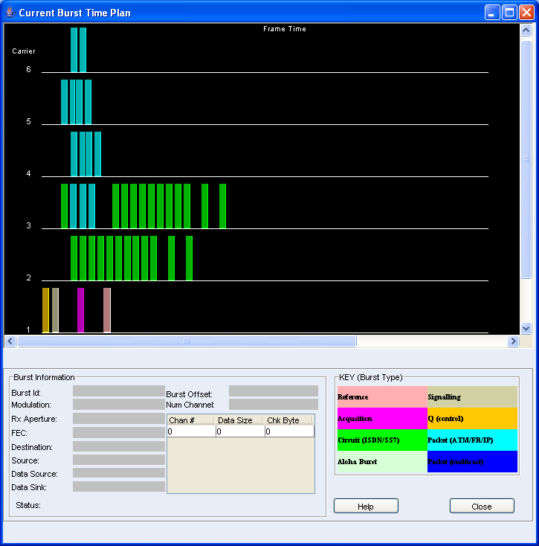
EXHIBIT 4.2: CURRENT BURST TIME PLAN

4.1.2 Accounting Management

The NMS User manages the accounting function through the Service History button on the NMS Home Page window.
Service History —Lists all service connections to all sites in the network, the interfaces at each site, and the transmission protocol installed at each interface.

4.1.3 Performance Management

The NMS User manages performance using the Performance, Diagnostic Tests, and Alarm buttons on the NMS Home Page window:
Performance—Allows viewing transmit and receive burst data from individual terminals in the form of statistics.
Diagnostic Tests—Allows a SuperUser to send diagnostic commands to a terminal or the NCC and view the results. Diagnostic testing is limited to identifying hardware-related problems associated with the terminals or service interfaces. The major diagnostic functions that can be executed via the NMS are:
- Verifying TDMA performance by displaying burst statistics.
2. Verifying IP performance by displaying IP STATS from the Performance window.
3. The system displays information for all active alarms on the network and identifies
failures at the interface card level.
4. Whenever a terminal goes down or the NMS loses its connection to the NCC.

4.1.4 Security Management

The NMS User manages security through the User Admin button, which allows adding and deleting NMS users and modifying their access privileges.
There are three levels of access privileges:
SuperUser— Access to all sites and facilities, including the NCC. Authorized to make network modifications and configuration changes.
Read Only—Read-only privileges on all parts of the network.
Restricted—Explicitly defined “read only” privileges.

4.1.5 Configuration Management

The NMS User manages the configuration of the network through the Configuration button. The NCC stores all the configuration information for the entire network. The NCC software reads the configuration information into memory (RAM) at network startup. The RAM copy is used during network operation. Configuration data specific to terminals are downloaded from the NCC to the terminals when the terminals are synchronized with the network.. Configuration Management has two basic elements:

- Site Configuration, which enables viewing and modifying:
All sites in the network and their details.
All terminals in the network and their details.
- Space Segment Configuration, which enables viewing and modifying the following elements:
- Satellite parameters.
- Control groups.
- Carrier administration.
- Static burst definitions.
- Data burst definitions.
- TDMA parameters.
- NCC operating parameters.
- Network parameters.
- Segmentation sequencing and scheduling parameters.
- Customer Administration
4.2 VERIFYING TDMA PARAMETERS

The cacgettxburstst command (alias = tb) issued to a TT, displays transmit burst statistics. The cacgetrxburstst (alias = rb) command issued to a reference or traffic terminal, displays receive burst statistics. These commands yield reports with the number of data segments transmitted on each burst and include the following information:

ID—Burst ID number assigned from burst time plan.
Detects—Number of times the TT receives the Reference burst from the MRT.
Misses—Number of times the TT attempted to receive the MRT’s Reference burst but was unsuccessful. If this number continues to grow for a long period of time, there could be an Rx-chain problem.
VitCorrs—Number of Viterbi corrections. If this number increases rapidly, it is an indication that the link has problems. Use the command rb in combination with the rx command (alias for prtstat rxacqsync—print receive synchronization statistics) to assess the state of the link.
Power—Level of RF power. This number should be as close to zero as possible. It ranges from –6 to +6. If –6 is displayed, the power is too low. If +6 is displayed, the power is too high.
RxSegs—Number of segments received.
RSCorrs—Number of Reed Solomon corrections. This should be very close to 0 (a
maximum of 10 to 20 per day).
CRCErrs— Cyclic redundancy check errors, the total number of uncorrectable errors. These statistical fields do not reset themselves periodically. The counters continue to accumulate unless they are commanded to clear. If one of the reported numbers appears exceptional, reset the counters with a clear command to view the rate of increase accurately.
To reset the counters, use the following commands:

The cacclearrxburstsst command clears the reported receive burst statistics and restarts the statistical counters.
The caccleartxaburstst command clears the transmit burst statistics. The alias command cb clears all burst statistics, including receive-and-transmit burst statistics.
The show_ber command sent to a terminal displays the raw BER for received reference and control bursts.

4.3 ADDING A PHYSICAL INTERFACE TO A NETWORK

Adding a physical interface to a terminal defines the physical connection of a Terrestrial Interface Unit (TIU). The physical interface is configured as part of the Site Configuration process that defines the equipment available at a site. There are a potential of three physical interfaces on each LINKWAY Terminal: One of the two interface card slots and one at the IP 10BaseT port. The card slots are labeled 0 and 1. Looking at the back of the terminal, INT 0 is the slot on the left and INT 1 is the slot on the right. The IP interface is automatically assigned Interface 2. When a terminal is added to a site, the IP physical interface is automatically entered in the configuration. Once physical interfaces are defined for a terminal, logical interfaces can be defined as part of the Services Configuration and mapped back to the physical interface. A physical interface is assigned to each logical interface, with the possibility of having multiple logical interfaces for one
physical interface. Additional physical interfaces are required for a redundant configuration.

4.4 IP SERVICE OPERATION

The traffic terminal coordinates with the NCC via PVC defined between the MRT and the traffic terminal. When a traffic requirement exists, the traffic terminal sends a connection request to the NCC. The NCC then checks both sending and receiving terminals to verify they are active (UP on the network). It also checks the IP interfaces to verify they are active. Any defined CIR for the PVC will be used first for sending the transmission. The NCC allocates additional bandwidth on an as-available basis, using bandwidth-on-demand algorithms, should more bandwidth be required. Multicast traffic uses the same process as unicast (single point to point), with the multicast PVC defining which terminals will receive the transmission. The NCC allocates bandwidth on demand to the multicast transmission, giving network priority to multicast traffic over unicast. Receiving terminals accept the transmission only if a client has requested it. Both features ensure efficient bandwidth usage in the network.

4.5 CONFIGURING IP LOGICAL INTERFACE
Configure the IP logical interface by completing the following parameters:
Site ID—Entered from the ADD Logical Interface window.
Logical IF—Entered from the ADD Logical Interface window.
IF Type—Entered from the ADD Logical Interface window.
MTU Size—Default = 1500 octets. Range = 524 – 1500
IP Address—To be assigned to this logical interface.
Subnet mask—To be applied when this interface logs onto the network.
Routing Protocol—Select from:
NONE— Packets will be routed only by destination address
RIP

4.6 ADDING A CARRIER
In the Carrier Definition window, enter appropriate information in the following fields:
Carrier ID—Enter a unique number from 0 – 254 to represent this carrier. This number will label the carrier on the Burst Time Plan and other carrier related reports.
Transponder ID—A numeric value 0 – 3. Default = 0. To use multiple transponders, a external transponder hopping switch must be attached to the Xponder Select port on the
back of the LINKWAY terminal.
Symbols/sec—Select the appropriate carrier rate from the drop-down menu. Four rates are currently supported, 625K/1.25M/2.5M/5 symbols/sec.
Default FEC—Select a default FEC rate from the drop-down menu. Rates supported: 1/1 (no coding), ½, 2/3, ¾, ⅞.

RF Frequency—Enter the frequency assigned to this carrier within the bandwidth assigned to the network.
Control Group Mapping—Assign the source and destination control groups if this carrier is to be dedicated to a transmission path.

TABLE 4.1: NMS/NCC MRT/TT PERFORMANCE CHECKS
TT INSTALLATION CHECKS

S.No. | Parameter | CHECKS/Test Procedure | Expected Result | Remark
1. | Switch on the power supply | Check the LED indicators on the Modem’s front panel | All LED should glow momentarily.
2 | Check TT status | Check SAT LED status | Steady Green— Terminal is both Rx and Tx synched  And ready to communicate with the network.
3 | Check the terminal configuration: | Check with the following  command:  dbpr siteconf | This gives the Site Details as configured on the NMS.
4 | Check that the site name, Site ID, latitude and longitude are correct. | command - tc | This gives the terminal details. Check the terminal name, Admin Status (should be enabled), QBID (should be 2,6 or a) and QBFrame ID (should be unique ‘, starting from 0,1,2... for each terminal).
5 | Check the boot file | command - dbpr rfportinfo | This gives the site’s ODU information.The TX RF Center frequency and & Rx RF Center frequency must EXACTLY match the TX & RX frequencies configured on the NMS.
6 | Check carrier information | Command - dbpr carrier. | This displays the carrier information expected by the terminal.
S.No. | Parameter | CHECKS/Test Procedure | Expected Result | Remark
7 | Check Burst statistics | Command rb. | Provides Burst statistics
8 | Check Status of power for network bursts. | Command : xs | Provides transmit and receive frequency offsets.
11 | Check BER | Command: show BER | Provides Raw BER statistics. Better than 10-7 at NCC

TABLE 4.2: TT PERFORMANCE TESTING

S.No. | Parameter | CHECKS/Test Procedure | Expected Result | Remark
A | Tx TEST
1 | Check for Tx acquisition burst being sent | Use command: tbtp -- issue command multiple times | look for AB burst being sent which indicates terminal is making effort to  transmit  AB will stop as terminal acquires. CB & SB continue.
2 | Check IF levels at various stages and adjust as required to achieve the desired BER/Eb/N0 | Check using Spectrum analyzer | Adjust the levels to achieve CBER of 10─7 at Far end
3 | Adjust IDU/L-band converter Power for the desired BER/Eb/N0 at far End (2.4M/3.8M/4.5M/6.3M/11M) for various TTs. | Note Power in coordination with Far end Stations | Adjust the levels to achieve CBER of 10─7 at Far end
B | Receive test | Sat LED should blink green initially, and then should go stable. | Receive OK
1 | Check Power levels using soft commands | Command : rs & rb | display power levels (value should be “0”+/- 12 )
2 | Internal attenuator | Command : rx | Internal attenuator setting ( value should be “20” – 42)
S.No. | Parameter | CHECKS/Test Procedure | Expected Result | Remark
3. | Check IF L levels at various stages. Adjust the Cxr levels/Far end TTs ( 2.4M/3.8M/4.5M/6.3M/11M) so as to achieve the desired CBER/Eb/N0 | Check using Spectrum analyzer | Adjust the levels at Far end to achieve CBER of 10─7
4 | Check Rx frequency | Command: dbpr  xponderstatus, | The LINKWAY terminal tracking frequency error of +/- 13 KHz for a 2.5 MSPS carrier,and 625 KSPS carrier, the range is +/- 3 KHz. For other carrier rates, the range is somewhere in between.  If the frequencies are beyond the limits adjust them accordingly
5 |  | Check for Rx CBER for various parameters like TB,SB,RB,QB etc | Better than 10-6 at NCC | If not adjust the Power levels of Remote and NCC as may be required to achieve the required BER

4.7 IP SERVICE FEATURES

The technology dynamically routes IP packets with RIP-1, RIP-2, OSPF, and BGP-4 protocols, and supports unicast and multicast services, as well as static and default routing. A native 10BaseT Ethernet connection simplifies connectivity between the terrestrial networking equipment and the terminal.
It has got following features:
- The system manages the routing table for IP and if allowed, dynamically assigns bandwidth as needed.
- When a point-to-multi-point burst is allocated for a data stream (multicast service), all network nodes designated in a “control group” receive the burst assignment.
- It allows multicast traffic bandwidth classified as real-time connections to be assigned a higher priority than unicast traffic. If required, the operator can specify a committed information rate for a unicast PVC, which will take priority over multicast traffic. Multicast traffic takes priority over unicast traffic, although unicast traffic with a committed information rate (CIR) will have reserved bandwidth that has highest priority.
- Internet protocols are the means by which a router gains information about the network. Routers determine the best path or route to get to the destination. The purpose of a router is effectively to supply efficient traffic flow and management of end-to-end packet flow. For IP, a terminal acts as a network router and routes each IP packet toward its destination. As a router, it broadcasts advertisement packets (signifying its presence) to all network nodes and communicates with the other routers regarding their network connections, the cost of connections, and traffic load levels.
- The network uses dynamic routing, which automatically reconfigures the routing table. Unlike a typical IP network, which supports only best-effort service, it also allows configuring minimum-guaranteed packet throughput between two sites. It also supports multicast routing, where a source terminal can send a single transmission to multiple terminals at the same time.
- The network supports most of the standard routing protocols, including:

4.7.1 Routing Information Protocol (RIP)
The major features of RIP include:
- The user datagram protocol is used to broadcast routing tables.
- A count of each router or gateway the packet needs to pass through—called a hop count—measures the distance between a source and destination. The maximum number of hops allowed is 15. A network is considered unreachable if it has 16 or more hops.
- Updates to routing tables are sent by routers every 30 seconds.
- Routes are timed out in 180 seconds unless an update for that path has arrived.
- RIP operates with two types of user devices: active and passive. Active users advertise their routes via a broadcast over their networks, while passive users listen and update their routes based on the RIP information, but do not advertise routes.
- The network is an active RIP user and advertises routes every 30 seconds. Within a RIP broadcast is a paired listing of every IP network the sender can reach and the distance, in hops, to that network. Within RIP, a router is defined to be one hop away from directly connected networks, two hops from networks that are reachable from one other router, and soon.

4.7.2 Border Gateway Protocol (BGP)

The capabilities of this protocol include:
- Facilitating communication between autonomous systems (ASs) by insuring that information about reaching entities within each AS is exchanged only with other ASs using the same protocol.
- An authentication method protects against unauthorized updates to routing tables. Policy-based routing is supported. Because a virtual connection is maintained between two hosts, the system exchanges an entire protocol routing table and table updates. Routers that belong to the same AS and exchange BGP updates are said to be running internal BGP (IBGP), and routers that belong to different ASs and exchange BGP updates are said to be running external BGP (EBGP).
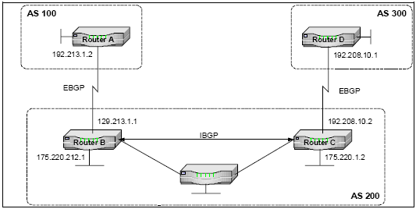

BGP ROUTING

4.7.3 Open Shortest Path First (OSPF)

This is a link-state protocol rather than a distance-vector protocol like RIP. Despite its name, OSPF supports user-definable, least-cost, multipath routing. This allows more optimized routing compared with distance-vector protocols. Each terminal in the network contains a routing directory database with information about the network’s operable interfaces. This information is periodically broadcast by the MRT to all traffic terminals in the network. As an OSPF router, the protocol computes the shortest path to the other terminals in the network, with itself as the root.
The system supports IP networking using an RJ-11 10BaseT Ethernet LAN port as the physical interface. All terminals come with a built-in IP interface. When a terminal is added to a site, the IP physical interface is automatically added to the network

4.8 OPERATOR ACTION ITEMS

- Add the new site with correct latitude/longitude and RF frequencies.
- Add a traffic terminal to the new site.
- Define service interfaces
- Add Logical Interface
- Add IP PVC between the MRT and the new traffic terminal.
- Assign CIR for link quality evaluation. (Delete after commissioning if not required).
- Create a boot file for the new traffic terminal.

4.9 INSTALLING STEPS TO SITE

- Site survey.
- Set up RFT.
- Point and peak antenna using appropriate tools and methods.
- Installing and commissioning IDU.

CHAPTER 5

5.1 THE NETWORKING IN ONGC

Networks and networking have grown exponentially over the last 15 years understandably so. They’ve had to evolve at light speed just to keep up with huge increases in basic mission critical user needs such as sharing data and printers, as well as more advanced demands such as video conferencing. Unless everyone who needs to share network resources is located in the same office area (an increasingly uncommon situation), the challenge is to connect the sometimes many relevant networks together so all users can share the networks’ wealth.
The purpose of networking is breaking up a large network into a no. of smaller ones is called network segmentation and is accomplished using routers, switches and bridges.

Possible causes of LAN traffic congestion:

- Too many hosts in a broadcast domain
- Broadcast storms
- Multicasting
- Low B/W
- Adding hubs for connectivity to the network

5.2 ROUTER

- Breaks broadcast domains
- Breaks collision domains
- They don’t forward broadcast by default
- They can filter the network using layer 3 information
- Packet switching
- Packet filtering
- Path selection

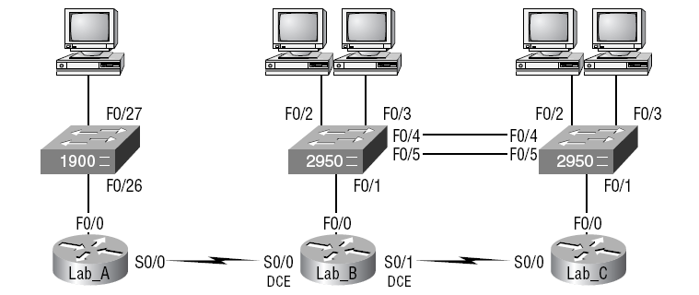
EXHIBIT 5.2: THE SAMPLE NETWORK

For LAB_A router adding interfaces as follows:

Router>en
Router#config t
Router(config)#hostname Lab_A
Lab_A(config)#enable secret todd
Lab_A(config)#interface fa0/0
Lab_A(config-if)#ip address 192.168.10.1 255.255.255.0
Lab_A(config-if)#no shut
Lab_A(config-if)#interface serial 0/0
Lab_A(config-if)#ip address 192.168.20.1 255.255.255.0
Lab_A(config-if)#clock rate 64000
Lab_A(config-if)#no shut
Lab_A(config-if)#exit
Lab_A(config)#line vty 0 4
Lab_A(config-line)#password todd
Lab_A(config-line)#login
Lab_A(config-line)#exit

Similarly we add interfaces to the other routers also. Now we need to run a routing protocol so that we no not have to put static routes which make our work easier. Hence we use the OSPF routing protocol.

Lab_A(config)#router ospf 1
Lab_A(config-router)#network 192.168.10.1 0.0.0.0 area 0
Lab_A(config-router)#network 192.168.20.1 0.0.0.0 area 0
Lab_A(config-router)#^Z
Lab_A#

Similarly we add ospf routes to other routers also and hence we could run the system without adding hectic static routes.

5.3 SWITCHES

- Breaks up collision domains
- Switch can be called a multiport bridge
- Makes a LAN work better to optimize performance providing more bandwidth for the LAN users
- Hardware address or MAC address based
- Uses ASIC.
- When a switch interface receives a frame with a destination H/W address that isn’t found in the devices filter table, it will forward to all connected segment

5.4 VIRTUAL LAN

Mail, Intranet, Internet and SAP Servers
8 MB
Leased
Line
Connected to Client PC1
Connected to Client PC2
Connected to Client PC3
VLAN 10
VLAN 19
VLAN 11
VLAN 4
Accelnet Server
TT1
TT2
TT3
Ethernet 1
VLAN 21
Internet
Proxy
Server
Port 8080
(ddn-ses1)
Cisco router
NMS PC
Cisco L2 Switch
MRT
NCC

VLAN 2
DEHRADUN
EXHIBIT 5.1: ONGC PHYSICAL DIAGRAM

Above is the physical diagram of ONGC in Exhibit 5.1. LAN switches when placed at the center of the network world and routers would be found connecting only logical networks together. This kind of a network is called a LAN.
Within the typical layer 2 switched internetwork, all users can see all devices by default. And one can’t stop devices from broadcasting, or users from trying to respond to broadcasts. Your security options are dismally limited to placing passwords on the servers and other devices. But not if you create a virtual LAN (VLAN). You can solve many of the problems associated with layer 2 switching with VLANs. There are several ways that VLANs simplify network management:

- Network adds, moves, and changes are achieved by configuring a port into the appropriate VLAN.
- A group of users needing high security can be put into a VLAN so that no users outside of the VLAN can communicate with them.
- As a logical grouping of users by function, VLANs can be considered independent from their physical or geographic locations.
- VLANs can enhance network security.
- VLANs increase the number of broadcast domains while decreasing their size.

All devices in a VLAN are members of the same broadcast domain and receive all broadcasts. The broadcasts, by default, are filtered from all ports on a switch that are not members of the same VLAN.

5.4.1 Security
It was basically the router’s job to maintain security. This arrangement was pretty ineffective for several reasons. First, anyone connecting to the physical network could access the network resources located on that physical LAN. Second, all anyone had to do to observe any and all traffic happening in that network was to simply plug a network analyzer into the hub. And third, in that same vein, users could join a workgroup by just plugging their workstations into the existing hub. So basically, this was non-security.
. By building VLANs and creating multiple broadcast groups, administrators can now have control over each port and user.

5.4.2 Flexibility and Scalability

If you create and implement VLANs, you’re essentially creating smaller broadcast domains at layer 2. This means that broadcasts sent out from a node in one VLAN won’t be forwarded to ports configured to be in a different VLAN. So by assigning switch ports or users to VLAN groups on a switch or group of connected switches, you gain the flexibility to add only the users you want into that broadcast domain regardless of their physical location. This setup can also work to block broadcast storms caused by a faulty Network Interface Card (NIC), as well as prevent an intermediate device from propagating the storms throughout the entire internetwork. Those evils can still happen on the VLAN where the problem originated, but the disease will just be quarantined to that one ailing VLAN.
Another advantage is that when a VLAN gets too big, you can create more VLANs to keep the broadcasts from consuming too much bandwidth—the fewer users in a VLAN, the fewer users affected by broadcasts.

5.4.3 VLAN Memberships
VLANs are usually created by an administrator, who then assigns switch ports to each VLAN. Such a VLAN is called a static VLAN. If the administrator wants to do a little more work up front and assign all the host devices’ hardware addresses into a database, the switches can be configured to assign VLANs dynamically whenever a host is plugged into a switch. This is called a dynamic VLAN. There are two different types of links in a switched environment:
Access links
This type of link is only part of one VLAN, and it’s referred to as the native VLAN of the port. Any device attached to an access link is unaware of a VLAN membership—the device just assumes its part of a broadcast domain, but it has no understanding of the physical network. Switches remove any VLAN information from the frame before it’s sent to an access-link device. Access-link devices cannot communicate with devices outside their VLAN unless the packet is routed.
Trunk links
Trunks can carry multiple VLANs and originally gained their name after the telephone system trunks that carry multiple telephone conversations. A trunk link is a 100- or 1000Mbps point-to-point link between two switches, between a switch and router, or between a switch and server. These carry the traffic of multiple VLANs—from 1 to 1005 at a time.
Trunking allows you to make a single port part of multiple VLANs at the same time. This can be a real advantage. For instance, you can actually set things up to have a server in two broadcast domains simultaneously, so that your users won’t have to cross a layer 3 device (router) to log in and access it. Another benefit to trunking is when you’re connecting switches. Trunk links can carry some or all VLAN information across the link, but if the links between your switches aren’t trunked, only VLAN 1 information will be switched across the link by default.
All VLANs are configured on a trunked link unless cleared by an administrator by hand.

5.4.4 VLAN Trunking Protocol (VTP)

Cisco created this one too, but this time it isn’t proprietary. The basic goals of VLAN Trunking Protocol (VTP) are to manage all configured VLANs across a switched internetwork and to maintain consistency throughout that network. VTP allows an administrator to add, delete, and rename VLANs—information that is then propagated to all other switches in the VTP domain. Here’s a list of some of the benefits VTP has to offer:

- Consistent VLAN configuration across all switches in the network

- Accurate tracking and monitoring of VLANs

- Dynamic reporting of added VLANs to all switches in the VTP domain

- Plug-and-Play VLAN adding

But before one can get VTP to manage your VLANs across the network, one have to create a VTP server. All servers that need to share VLAN information must use the same domain name, and a switch can be in only one domain at a time. So this means that a switch can only share VTP domain information with other switches if they’re configured into the same VTP domain. One can use a VTP domain if you have more than one switch connected in a network, but if you’ve got all your switches in only one VLAN, you don’t need to use VTP. VTP information is sent between switches via a trunk port.
And there’s also something called VTP transparent mode. In it, one can configure switches to forward VTP information through trunk ports, but not to accept information updates or update their VTP databases. The purpose of Transparent mode is to allow remote switches to receive the VLAN database from a VTP Server configured switch through a switch that is not participating in the same VLAN assignments.

VTP Modes of Operation

There are three different modes of operation within a VTP domain.

Server

This is the default for all Catalyst switches. You need at least one server in your VTP domain to propagate VLAN information throughout the domain. The switch must be in server mode to be able to create, add, or delete VLANs in a VTP domain. Changing VTP information must also be done in server mode, and any change made to a switch in server mode will be advertised to the entire VTP domain.

Client
In client mode, switches receive information from VTP servers, and they also send and receive updates. But they can’t make any changes. Plus, none of the ports on a client switch can be added to a new VLAN before the VTP server notifies the client switch of the new VLAN. It’s also good to know that VLAN information sent from a VTP server is not stored in NVRAM.

VTP Pruning
VTP provides a way for you to preserve bandwidth by configuring it to reduce the amount of broadcasts, multicasts, and unicast packets. This is called pruning. VTP pruning only sends broadcasts to trunk links that truly must have the information. Here’s an example: If Switch A doesn’t have any ports configured for VLAN 5, and a broadcast is sent throughout VLAN 5, that broadcast would not traverse the trunk link to Switch A. By default, VTP pruning is disabled on all switches. When you enable pruning on a VTP server, you enable it for the entire domain. By default, VLANs 2 through 1005 is pruning-eligible, but VLAN 1 can never prune because it’s an administrative VLAN. You can’t change, delete, or rename VLAN 1, because it’s the default VLAN and you just can’t change that—period. It’s the native VLAN of all switches by default, and Cisco recommends that you use this as your administrative VLAN. Native VLAN basically means that any packets that aren’t specifically assigned to a different VLAN will be sent down the native VLAN. It really is a good idea to configure your VLANs as separate subnets. Please remember that all switches are set to VTP server mode by default, and if you want to change any VLAN information on a switch, you must be in VTP server mode. Two switches will never communicate in an VLAN environment if their VTP domain names are different. A VTP client cannot create, delete, add, or change VLANs. VTP clients only keep the VTP database in RAM and that’s not saved to NVRAM. So, in order to create a VLAN on this switch, you’ve got to make the switch a VTP server first.

How to configure routers and switches for VLANs:

As we have seen how to configure routers and using the same Exhibit 5.2 we configure the switches also for the VLANs. Our internetwork has two 2950s interconnected and ready for us to configure VLANs. The 2950 connected to the Lab_C router is named 2950C and the 2950 connected to the Lab_B router 2950B. For the management VLAN (VLAN 1), 172.16.10.0/24 network is used, with the fa0/0 interface of Lab_B being the router port is used to configure inter-VLAN routing. Each switch must have an IP address in the 172.16.10.0 subnet configured to be able to communicate. There are two more VLANs: VLAN 2 will have the subnet 172.16.20.0/24 and VLAN 3 will have the subnet 172.16.30.0/24.

Switch>en
Switch#config t
Enter configuration commands, one per line. End with CNTL/Z.
Switch(config)#hostname 2950C
2950C(config)#enable secret todd
2950C(config)#line con 0
2950C(config-line)#login
2950C(config-line)#password console
2950C(config-line)#line vty 0 15
2950C(config-line)#login
2950C(config-line)#password telnet
2950C(config-line)#banner motd #
Enter TEXT message. End with the character '#'.
This is my 2950C switch
#
2950C(config)#int f0/1
2950C(config-if)#description Connection to router
2950C(config-if)#interface f0/4
2950C(config-if)#description Connection to 2950B
2950C(config-if)#int f0/5
2950C(config-if)#description 2nd connection to 2950B
2950C(config-if)#int vlan1
2950C(config-if)#ip address 172.16.10.2 255.255.255.0
2950C(config-if)#no shut
2950C(config-if)#exit
2950C(config)#ip default-gateway 172.16.10.1
2950C(config)#^Z
2950C#copy run start
Destination filename [startup-config]? [Enter]
Building configuration...
[OK]
2950C#

Similarly for 2950B switch we add details. The two switches are configured with all the basic administrative information and can ping each other, the trunking up on the port connecting to the router follows:

2950B#config t
2950B(config)#int f0/1
2950B(config-if)#switchport mode trunk
2950B(config-if)#int f0/4
2950B(config-if)#switchport mode trunk
2950B(config-if)#int fa0/5
2950B(config-if)#switchport mode trunk
2950B(config-if)#exit

Similarly for 2950c router:

2950C#config t
Enter configuration commands, one per line. End with CNTL/Z.
2950C(config)#int fa0/4
2950C(config-if)#switchport mode trunk
2950C(config-if)#int fa0/5
2950C(config-if)#switchport mode trunk
2950C(config-if)#

We can verify our trunk information on each switch with the show interface trunk command:
2950B#sh int trunk
Port Mode Encapsulation Status Native vlan
Fa0/1 on 802.1q trunking 1
Fa0/4 on 802.1q trunking 1
Fa0/5 on 802.1q trunking 1
[output cut]

We’ve configured both switches with administrative information and set the trunk ports, and verified it all. On the 2950C switch, let’s set the VTP information and then create two VLANs:
2950C#config t
Enter configuration commands, one per line. End with CNTL/Z.
2950C(config)#vtp mode server
Device mode already VTP SERVER.
2950C(config)#vtp domain RouterSim
2950C(config)#vlan 2
2950C(config-vlan)#name Sales
2950C(config-vlan)#vlan 3
2950C(config-vlan)#name Marketing

In the above configuration, the VTP information has to be set before we create our VLANs because we could end up with a problem with the VTP database. We can easily verify that our changes took effect by using the show vlan brief command:

2950C#sh vlan brief

VLAN Name Status Ports
---- ----------------- --------- ------------------------------
1 default active Fa0/1, Fa0/2, Fa0/3, Fa0/4
Fa0/7, Fa0/8, Fa0/11, Fa0/12
2 Sales active
3 Marketing active
[output cut]

There’s one more configuration on the 2950C switch: setting the interfaces to the VLAN memberships. Interface fa0/2 will be in VLAN 2, and int fa0/3 will be in VLAN 3. Remember that all ports are in VLAN 1 unless set otherwise.

2950C#config t
2950C(config)#int fa0/2
2950C(config-if)#switchport access vlan 2
2950C(config-if)#int fa0/3
2950C(config-if)#switchport access vlan 3

To verify our VLAN information on the 2950C switch:
2950C#sh vlan brief
VLAN Name Status Ports
---- --------------------- --------- ----------------------------
1 default active Fa0/1, Fa0/4, Fa0/5, Fa0/6
Fa0/7, Fa0/8, Fa0/9, Fa0/10
2 Sales active Fa0/2
3 Marketing active Fa0/3

Similarly we have to configure our 2950B switch with VTP information and assign the ports. Remember that the purpose of setting the VTP information is to ensure that all switches share the same VLAN database. This means that you only set your VLANs once and all switches will build their VLAN databases from the VTP server. 2950B is a VTP client. Noticed that we had to set the domain information before changing the switch from VTP server mode to client mode. Let’s check and make sure our 2950B switch has received the VLAN information from the VTP server (2950C):
Yes, the 2950B switch knows about the VLANs. We still need to set the VLAN memberships, then move onto the router configuration:

2950B#config
2950B(config)#int fa0/2
2950B(config-if)#switchport access vlan 2
2950B(config-if)#int fa0/3
2950B(config-if)#switchport access vlan 3
And let’s verify our VLAN information on the 2950B switch:
2950B#sh vlan brief
VLAN Name Status Ports
---- -------------------- --------- ----------------------------
1 default active Fa0/1, Fa0/4, Fa0/5, Fa0/6
Fa0/7, Fa0/8, Fa0/9, Fa0/10
2 Sales active Fa0/2
3 Marketing active Fa0/3

Both switches are completely configured, and we verified that it’s all good. The hosts can only communicate with hosts that are members of the same VLAN. So what this means to us is that the hosts in ports fa0/2 can communicate only with each other—same with the hosts in ports fa0/3. We’re not done yet! We want it all, and if we want to have all our hosts talking, we need a router or layer 3 switch to make that happen.
In this example, we’re going to use the Lab_B router to configure inter-VLAN communication.
Router>enable
Router#config t
Enter configuration commands, one per line. End with CNTL/Z.
Router(config)#hostname Trunkrouter
Trunkrouter(config)#int f0/0
Trunkrouter(config-if)#no ip address
Trunkrouter(config-if)#no shutdown
Trunkrouter(config-if)#int f0/0.1
Trunkrouter(config-subif)#ip address 172.16.10.1 255.255.255.0
Configuring IP routing on a LAN subinterface is only allowed if that subinterface is already configured as part of an IEEE 802.10, IEEE 802.1Q, or ISL VLAN.
Trunkrouter(config-subif)#encapsulation dot1q 1
Trunkrouter(config-subif)#ip address 172.16.10.1 255.255.255.0
Trunkrouter(config-subif)#int f0/0.2
Trunkrouter(config-subif)#encap dot1q 2
Trunkrouter(config-subif)#ip address 172.16.20.1 255.255.255.0
Trunkrouter(config-subif)#int f0/0.3
Trunkrouter(config-subif)#encap dot1q 3
Trunkrouter(config-subif)#ip address 172.16.30.1 255.255.255.0
Trunkrouter(config-subif)#exit

When configuring this router, I created three subinterfaces—one for each VLAN.
Remember that the subinterface number isn’t really important except for administration, but I did match it to each VLAN number so it’s easy to remember. Also, notice that when
I tried to set an IP address on the first subinterface, it gave me the following error message until I set the encapsulation type:
Configuring IP routing on a LAN subinterface is only allowed if that subinterface is already configured as part of an IEEE 802.10, IEEE 802.1Q, or ISL VLAN.

5.5 ETHERNET

- It is a contention media access method that allows all hosts on a network to share the same B/W of a link.
- It uses Carrier Sense Multiple Access with Collision Detection (CDMA/CD)
- Back off algorithms determine when the colliding stations can retransmit
- 10BaseT gives 3 to 4 Mbps at most
- If a hub is connected to a switch, it must operate in a half duplex mode
- Ethernet at the data link layer is responsible for Ethernet addressing i.e. MAC addressing

5.5.1 Cabling

Straight through cable: It is used to connect host to switch or router or router to switch or hub.

- 1
- 2
- 3
- 6

Crossover cable: It is used to connect a switch to a switch or a host to a host or a hub to a hub or a host to a host or a router direct to host.

- 1
- 2
- 3
- 6

Rolled cable: To connect host to a router console serial communication port.

- 1
- 2
- 3

. .
. .
7 7
8 8

5.5.2 Some protocols

TELNET: It is a chameleon of protocols and its specialty is terminal emulation. It allows a user on a remote client machine called the telnet client to access the resources of another machine- the telnet server. Users begin a login session by running client software and then logging into the telnet server.

FTP: Lets us transfer files and it can accomplish this between two machines using it. It is limited to listing and manipulating directories, typing file contents and copying files between hosts. It can’t execute remote files as programs.

ICMP: Management protocol and messaging service provider for IP. Some common events and messages that ICMP relates to:
- Destination unreachable
- Buffer full
- Hops
- Ping (packet internet groper): Use ICMP echo messages to check physical and logical connectivity of machines on an internetwork.

TRACEROUTES: Using ICMP timeouts traceroute is used to discover the path a packet takes as it traverses an internetwork.

ARP: If IP doesn’t find the destination hosts hardware in the ARP cache it uses ARP to find this information. As IP’s detective, ARP interrogates the local network by sending out a broadcast asking the machine with the specified IP address to reply with its hardware address.

REVERSE ADDRESS RESOLUTION PROTOCOL (RARP): When an IP machine happens to be a diskless machine, it has no way of initially knowing its IP address. RARP discovers the identity of the IP address for diskless machine by sending out a packet that includes its MAC address and a request for the IP address assigned to that MAC address.

PROXY ARP: On a network your hosts can’t have more than one default gateway configured. If the gateway goes down proxy ARP can actually help machines on a subnet reach remote subnets without configuring routing or a default gateway.

NAT: If every host on every network had to have a real routable IP addresses, we would have run out of IP addresses to hand out years ago. But by using private IP addresses, ISPs, Corporations and home users only need a relatively tiny group of bonafide IP address to connect their networks to the internet. For this Network Address Translator (NAT) which basically takes a private IP address and converts it for use on the internet. Hence NAT
- Conserves IP addresses
- Increases network security

REFERENCES

- Various manuals available for the MF-TDMA system.

- Book on digital satellite communication by Tri T. Ha.
- CCNA™: Cisco® Certified Network Associate Study Guide, 5th Edition by Todd Lammle.

